Corey the Camel
Student name:_____________________________________________________________
Grading | Comments and Points
Opening and Closing Paragraphs | ______/10pts
Paragraphs  At least 3, with 5 sentences in each paragraph | _______/5pts
Spelling/ Grammar | _______/10pts
Bananas carried across OR Excessive # of Bananas left behind | _______/20pts
Accurate Solution  Mistakes will be taken off accordingly (students with most bananas will get an extra 10 points) | _______/50pts
Explanation | _______/ 100 pts
Neatness | ________/ 5pts
Total Score: | ___________/200

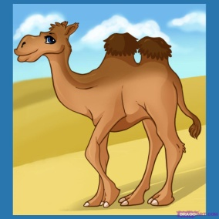Corey the Camel

Corey the camel can carry 1,000 bananas at a time. Corey also eats one banana every mile that he walks. Corey has been employed to transport as many bananas as possible to a market that is 1,000 miles away. He must walk at all times and has no helpers. Corey has 10,000 bananas that may be transported. How many bananas can Corey get to the market?

- Draw a number line type chart to illustrate Corey’s stops along the way to the market and what he did at each stop.
- Write an essay that explains how you solved this problem. Be sure to include an opening paragraph and to check for spelling and grammatical errors.
- Look at the grading rubric and organize your essay accordingly.

